**D2 - Evaluate the web pages and discuss improvements**

**Introduction**

In this report, I will evaluate the web pages and discuss any improvements that I need to make.

**Good Points**

The good points that I think of my website is the search bar and gallery. They are both useful because users can search up on google what they want on my website. It is very useful for others. Gallery is very useful as it shows others different pictures of Gerrard. I also like how I have updated the Videos. These videos can be updated for the users. Users like to have the latest videos where they can watch highlights of any game. I can do this by updating it. As you can see below, Wilshere’s goal is the latest goal scored on the 7th June 2015. Any Barclays Premier League game, which the season is finished, can be updated on the Videos page too.

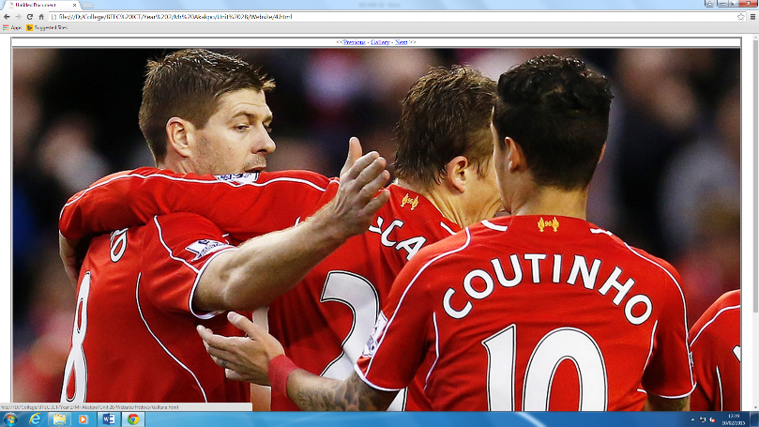

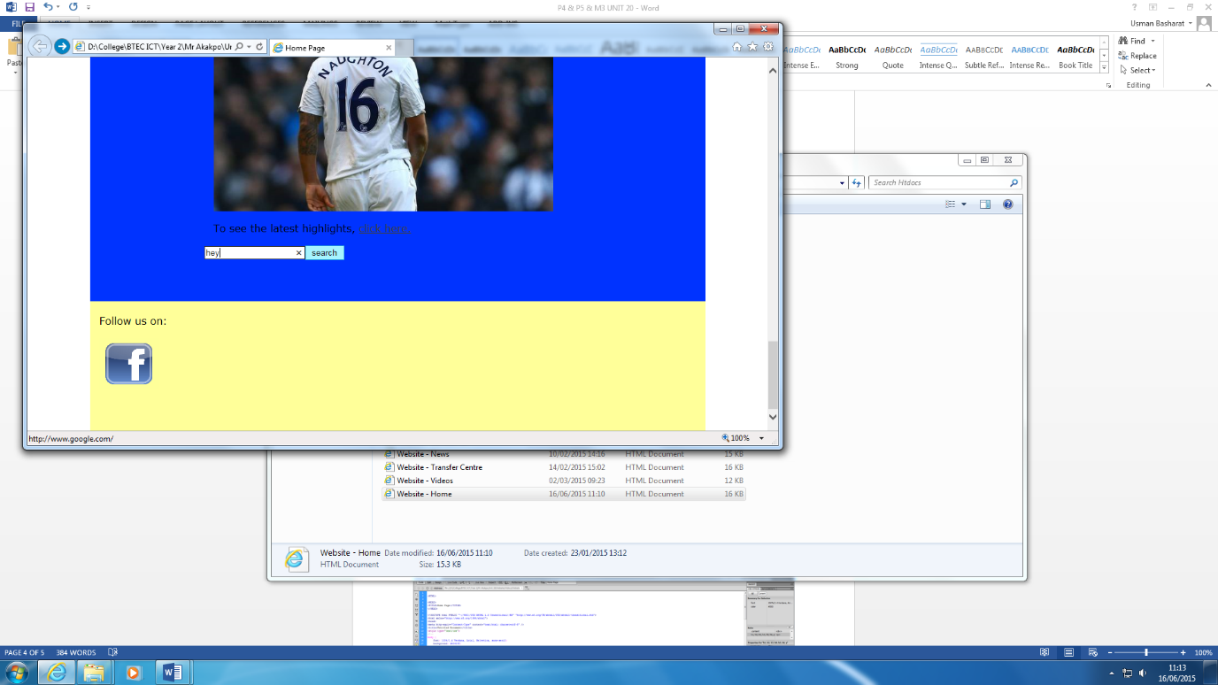

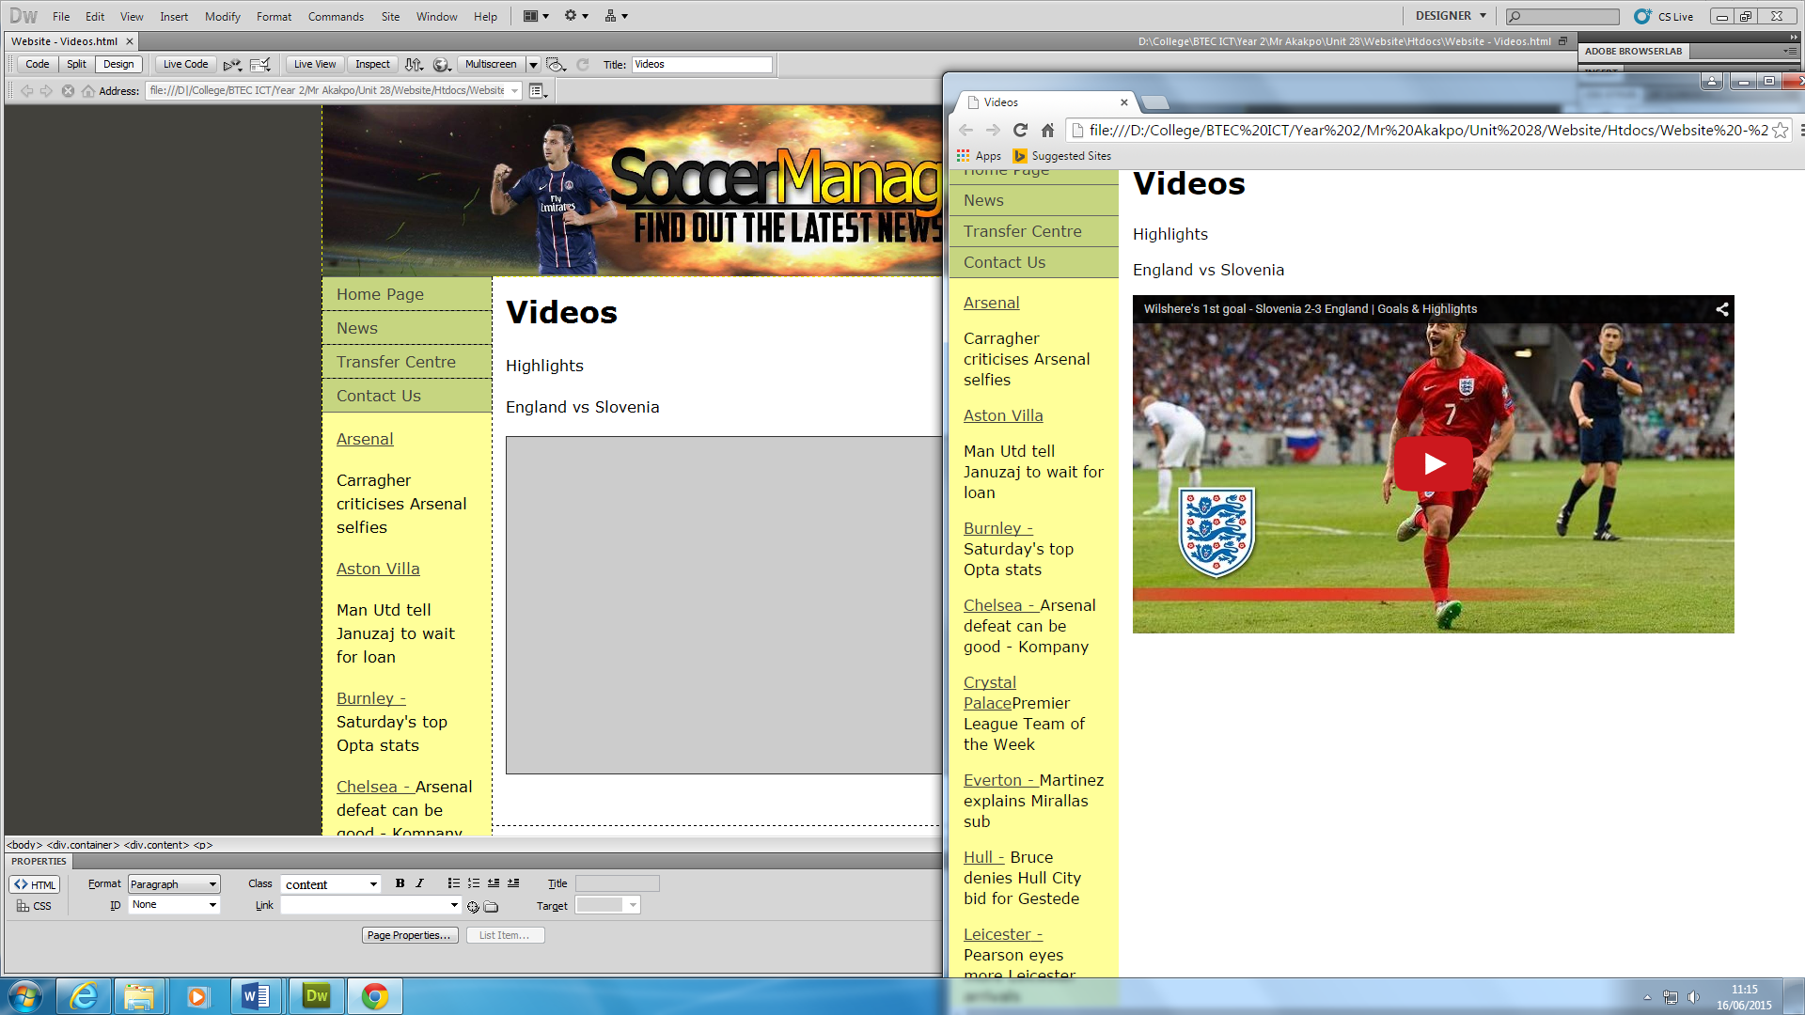

**Bad Points**

The bad points of my website is the Navigation Bar. I feel that I can improve this better. It is on the side and many users would not recognise it being the navigation bar. It is plain too. I feel this is the only part of my website where I could improve. I could improve the background too. One of my colleagues have pointed out these bad points too.



**Possible Improvements**

The improvements that I face is the background and the navigation bar. I could make it more professional by making it horizontal rather than it is currently. I feel that it is plain and needs to be added on to.

[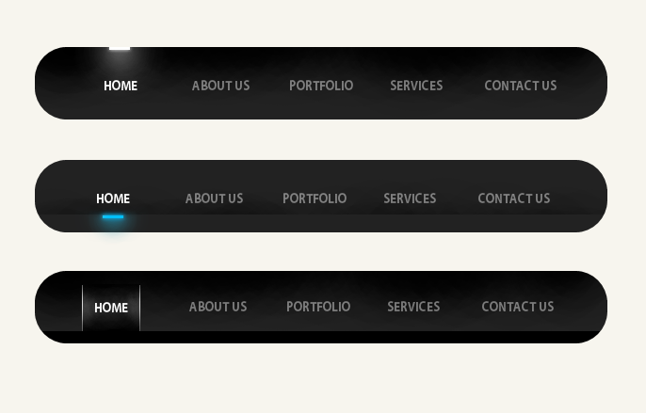](http://www.google.co.uk/url?sa=i&rct=j&q=&esrc=s&source=images&cd=&cad=rja&uact=8&ved=0CAcQjRxqFQoTCOn5uLCclMYCFW4W2wod1ngArg&url=http%3A%2F%2Fwww.v7n.com%2Fforums%2Fgraphic-design-forum%2F198159-nav-bar-design-feedback-plz.html&ei=dxeAVaniCu6s7AbW8YHwCg&bvm=bv.96041959,d.ZGU&psig=AFQjCNF8tJGyJy84VFZc8eoJf1GjIwo4Aw&ust=1434544372410547)Even though the Home Page is blue, I could mixture it up with two colours. It would look way better. An example is shown below. If any possible improvements, I could make the navigation bar like it is below. An example of one of the wallpaper is shown below.

[](http://www.google.co.uk/url?sa=i&rct=j&q=&esrc=s&source=images&cd=&cad=rja&uact=8&ved=&url=http%3A%2F%2Fes.forwallpaper.com%2Fwallpaper%2Fblue-background-circles-317388.html&ei=qxeAVczIKM-Q7AawmYCACw&psig=AFQjCNEvpjWNbowEUFngGRsFJ2L7NzBlNQ&ust=1434544427997010)